**Running code:**   
in order to run the code you will need to import the project into eclipse or copy all .java and dataset files  
the project contains some configuration to eclipse which is very easy to configure I will show the steps  
  
after copying all classes into eclipse, make sure the datasets are also loaded into the project  
the project should look something like this  
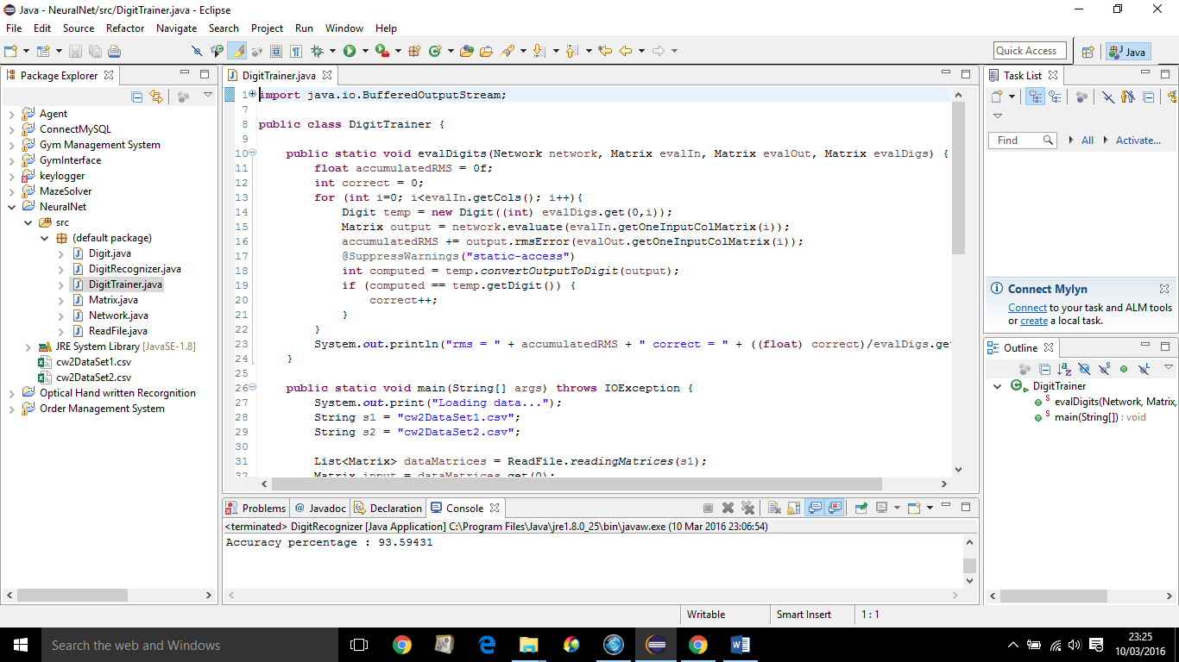

Now open the DigitRecognizer.java and navigate to run configuration

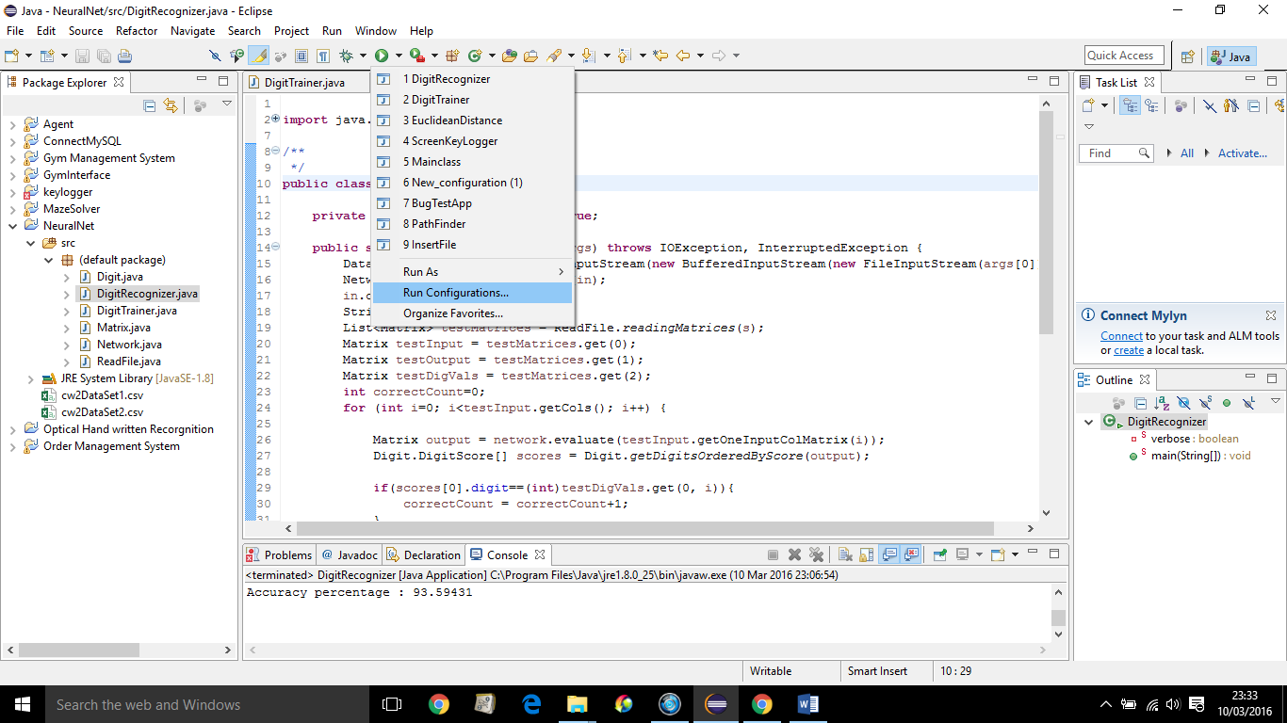

And then go to arguments, and at the program arguments type outputNet and click apply

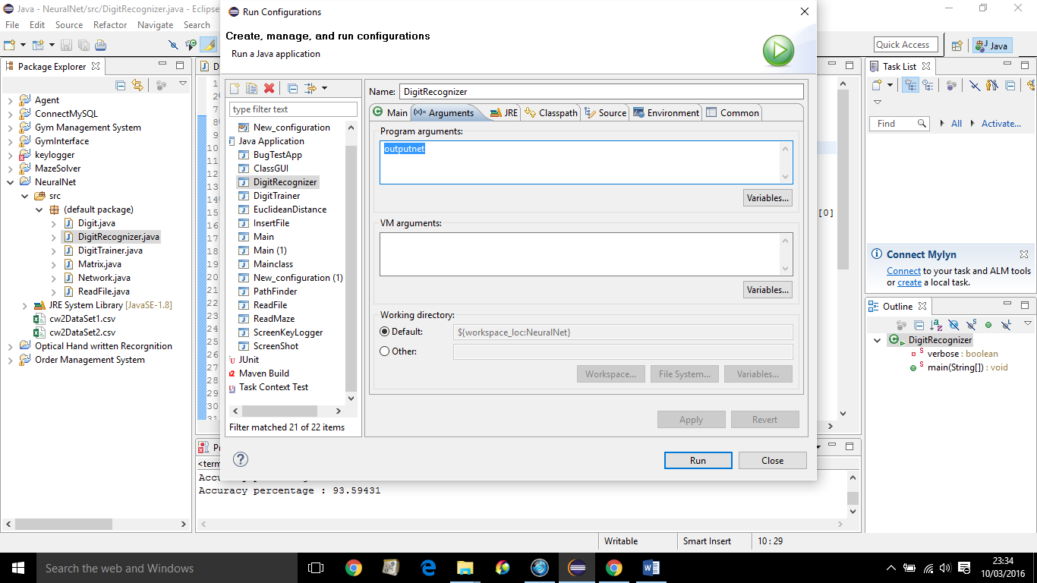

outputNet file is the file that contains the trained neural network, I configured the testing file to take a trained NN as input and classify the test examples

Now run the DigitTrainer.java, this class will train the NN and create the outputNet file.

Now you can run the DigitRecognizer.java and the expected result is 93%